Importing libraryes

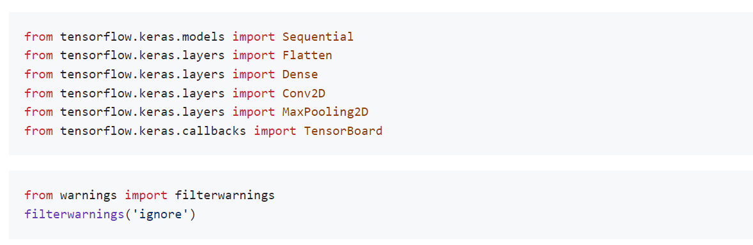

Network Parameter:

* Rectifier Linear Unit
* Adam optimizer
* Sigmoid on Final output
* Binary CrossEntropy loss

